PROJECT REPORT

LICENSED SOFTWARE REQUEST MANAGEMENT

ServiceNow Service Catalog and Network Request Automation

Date: 9 September 2026
Student Name: Burada Laxmi Sai Priyanka

Project Documentation
Prepared based on the implemented project and reference report structure.
Technology: ServiceNow
Application: LICENSED SOFTWARE REQUEST MANAGEMENT
Project: Automated Licensed Software Installation Request Management

Table of Contents
1. INTRODUCTION
1.1 Project Overview
1.2 Purpose
2. IDEATION PHASE
2.1 Problem Statement
2.2 Empathy Map Canvas
2.3 Brainstorming & Idea Prioritization
3. REQUIREMENT ANALYSIS
3.1 Customer Journey Map
3.2 Solution Requirements
3.3 Logical Data Flow
3.4 Technology Stack
4. PROJECT DESIGN
4.1 Problem–Solution Fit
4.2 Proposed Solution
4.3 Solution Architecture
5. PROJECT PLANNING & SCHEDULING
5.1 Project Planning
6. FUNCTIONAL AND PERFORMANCE TESTING
6.1 Functional Testing
6.2 User Acceptance Testing
6.3 Performance Testing
7. RESULTS
The following figures present the implementation evidence captured from the ServiceNow project. They cover catalog configuration, submitted variables, workflow automation, approvals, fulfillment, SLA/testing evidence, and deployment/update-set evidence.
7.1 Output Screenshots
7.2 Work Item Status Validation
8. ADVANTAGES & DISADVANTAGES
9. CONCLUSION
10. FUTURE SCOPE
11. APPENDIX

1. INTRODUCTION

1.1 Project Overview
The Licensed Software Installation Request system is a ServiceNow-based solution designed to simplify and automate the process of requesting installation of licensed software. Employees can submit software installation requests through a centralized Service Catalog. The system captures required information such as software name, software version, business justification, required date, employee, target device, manager, department, urgency, and license type.
After submission, ServiceNow creates the request records and processes the request through an automated workflow. The workflow retrieves catalog variables, evaluates the request, validates license information, routes the request for approval, and creates a Software Installation Catalog Task after the required approvals are completed. The task is assigned to the Software Support Team for fulfillment.
High-Level Flow
Employee → Service Catalog → REQ/RITM → License Validation → Approval → Software Asset Approval → Catalog Task → Software Support Team → Installation → Notification → Closure
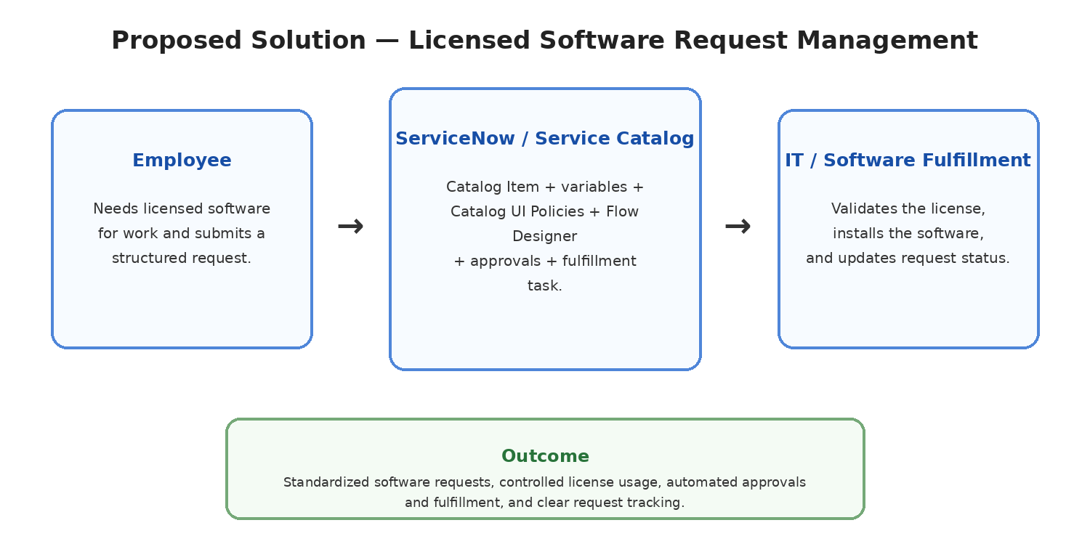
Figure 1: High-level workflow of the Licensed Software Installation Request System.

1.2 Purpose
The purpose of this project is to provide a centralized and structured process for managing licensed software installation requests.
The system aims to:
- Simplify licensed software request submission.
- Capture complete software and employee information.
- Validate license availability before fulfillment.
- Automate approval processing.
- Automatically create software installation tasks.
- Assign tasks to the Software Support Team.
- Improve request tracking and visibility.
- Provide SLA and notification support.
- Maintain controlled access through ServiceNow roles and ACLs.

2. IDEATION PHASE

2.1 Problem Statement
Employees may face difficulties when requesting licensed software because requests can be submitted through unclear or unstructured processes. Incomplete information, missing license checks, manual approvals, and manual task assignment can cause delays in software installation and make request tracking difficult.
Problem Statement Canvas
Parameter | Description
User | Employees requesting licensed software
Problem | Software requests may be incomplete or lack licensing information
Need | A simple and structured request process
Impact | Delays in validation, approval, and installation
How Might We? | How might we provide a centralized system for requesting, validating, approving, and installing licensed software efficiently?

2.2 Empathy Map Canvas
Employee / End User Perspective
Dimension | Employee Perspective
Says | I need a simple way to request the software I require.
Thinks | I want a clear form with relevant software and installation options.
Does | Opens the portal, selects the Licensed Software Installation Request, and submits details.
Feels | Wants fast, reliable, and transparent software support.
Pain Points | Incomplete forms, unclear approval status, license uncertainty, and delayed fulfillment.
Needs / Goals | Simple submission, clear tracking, timely approval, and successful installation.

2.3 Brainstorming & Idea Prioritization
Idea | Priority
Licensed Software Request Catalog Item | High
Catalog Variables | High
Catalog UI Policies | High
Catalog Client Scripts | High
License Validation | High
Approval Process | High
Flow Designer / Workflow Automation | High
Software Installation Task | High
Software Support Team Assignment | High
Notifications | Medium
SLA Monitoring | Medium
Reports and Dashboards | Medium
ACLs and User Roles | High

3. REQUIREMENT ANALYSIS

3.1 Customer Journey Map
The employee journey begins when the user accesses the Service Portal and ends when the licensed software request is fulfilled.
Stage | Employee Action | System Response
Access | Opens Service Portal | Portal displays available services
Discover | Finds Licensed Software Installation Request | Catalog item is displayed
Submit | Enters request details | Variables capture information
Validate | Completes required fields | UI Policies and Client Scripts validate the form
Process | Submits request | REQ and RITM are created
License Check | Waits for validation | Workflow checks configured license information
Approval | Waits for approval | Approval workflow is triggered
Fulfillment | Request is processed | Software Installation Task is created
Completion | Receives completed service | Task and request status are updated

3.2 Solution Requirements

Functional Requirements
ID | Requirement
FR-01 | Employees shall access the Licensed Software Installation Request Catalog Item.
FR-02 | The system shall capture required software and requester information.
FR-03 | The system shall validate mandatory fields.
FR-04 | Relevant fields shall be displayed or controlled dynamically.
FR-05 | The system shall create REQ and RITM records after submission.
FR-06 | The request shall undergo license validation.
FR-07 | The request shall be sent for approval.
FR-08 | A Software Installation Task shall be created after required approval.
FR-09 | The Software Support Team shall process the assigned task.
FR-10 | The system shall send relevant notifications and update request status.

Non-Functional Requirements
ID | Requirement
NFR-01 | The system should provide a simple user interface.
NFR-02 | The system should use ServiceNow access controls.
NFR-03 | The workflow should process requests consistently.
NFR-04 | The system should provide normal ServiceNow response performance.
NFR-05 | The configuration should be maintainable and deployable through an Update Set.

3.3 Logical Data Flow
Employee Input → Catalog Variables → Service Catalog → REQ/RITM → Workflow → License Validation → Approval → Catalog Task → Software Support Team → Task Completion → Notifications / Dashboard
Figure 3: Logical data flow of the Licensed Software Installation Request process.

3.4 Technology Stack
S.No. | Component | Description | Technology
1 | User Interface | Employee-facing request interface | Service Portal / Service Catalog
2 | Catalog | Licensed software request submission | Service Catalog
3 | Variables | Software and installation information | Catalog Variables
4 | Rules | Dynamic fields and validation | Catalog UI Policies / Client Scripts
5 | Automation | Approval and workflow processing | Flow Designer / Workflow
6 | Data | Request and fulfillment records | REQ / RITM / Catalog Tasks
7 | References | User and group information | sys_user / sys_user_group
8 | Licensing | Software license validation | License / software asset records
9 | Communication | Request event messages | ServiceNow Notifications
10 | Monitoring | Time-based processing targets | SLA
11 | Security | Controlled access | Roles / ACLs
12 | Deployment | Configuration packaging | Update Set

4. PROJECT DESIGN

4.1 Problem–Solution Fit
Parameter | Project Fit
Problem | Employees need a simple and structured way to request licensed software.
Solution | A ServiceNow-based Licensed Software Installation Request system.
Customer Benefit | Guided request entry, approval visibility, and predictable fulfillment.
Operational Benefit | Structured requests improve licensing checks, approvals, and installation.
Uniqueness | Combines Service Catalog, UI controls, license validation, approvals, automation, and task fulfillment.
Scalability | Additional software products, approval levels, and deployment integrations can be added later.

4.2 Proposed Solution
The proposed solution is a ServiceNow-based Licensed Software Installation Request system. Employees submit software installation requests through a dedicated Catalog Item. Catalog Variables capture request information, while UI Policies and Catalog Client Scripts support validation and dynamic form behavior.
After submission, the request is processed by SIRA_Software_Installation_Workflow. The workflow retrieves catalog variables, evaluates priority, performs license lookup, routes approval, and proceeds through software asset approval. Once the request is approved and validated, a Software Installation Catalog Task is created and assigned to the Software Support Team.
Notifications communicate approval, assignment, decision, and completion events. SLAs provide time-based monitoring, while the dashboard provides operational visibility.

4.3 Solution Architecture
The solution architecture connects the Service Portal, Licensed Software Request Catalog Item, catalog variables, validation rules, license information, approval process, workflow automation, Software Installation Tasks, notifications, SLAs, security, and dashboard reporting.
Service Portal → Catalog Item → Catalog Variables → REQ/RITM → SIRA Workflow → License Validation → Approval → Asset Approval → Software Installation Task → Software Support Team → Completion → Notifications / Dashboard
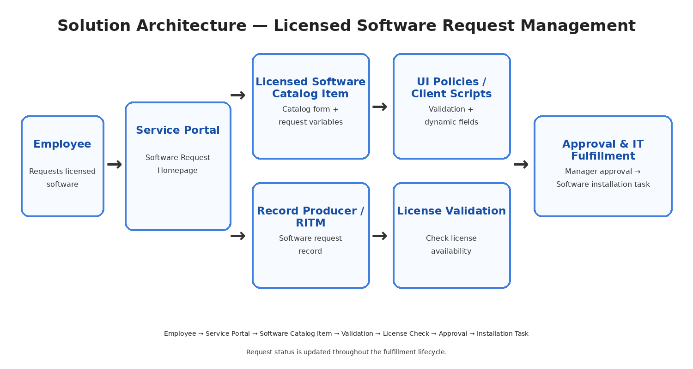
Figure 4: Solution architecture of the Licensed Software Installation Request System.

5. PROJECT PLANNING & SCHEDULING

5.1 Project Planning
The project was divided into six implementation phases to provide a structured development and validation sequence.
Phase | Functional Area | Major Activities | Priority
Phase 1 | Requirement Analysis & Planning | Requirements, roles, workflow, approvals, licensing, SLA and security. | High
Phase 2 | Service Catalog & Form Configuration | Catalog item, variables, request records and form structure. | High
Phase 3 | UI/UX Development & Customization | UI Policies, Catalog Client Scripts and form behavior. | High
Phase 4 | Workflow Automation & Approval | Workflow, license validation, approvals and task creation. | High
Phase 5 | Testing & Security | Functional testing, UAT, SLA, notification and security validation. | High
Phase 6 | Deployment, Documentation & Final Presentation | Update Set, deployment validation, dashboard, documentation and final demonstration. | High

6. FUNCTIONAL AND PERFORMANCE TESTING

6.1 Functional Testing
Test ID | Scenario | Expected Result | Status
TC-01 | Open Service Portal | Portal loads successfully | Pass
TC-02 | Find Licensed Software Request | Catalog item is visible | Pass
TC-03 | Open request form | Form opens successfully | Pass
TC-04 | Enter request details | Variables are available | Pass
TC-05 | Validate fields | Mandatory validation works | Pass
TC-06 | Submit request | REQ and RITM are created | Pass
TC-07 | License validation | Configured license check is executed | Pass
TC-08 | Approval process | Request goes for approval | Pass
TC-09 | Create Software Installation Task | Task is created after approval | Pass
TC-10 | Assignment | Task is assigned to Software Support Team | Pass
TC-11 | Notification | Configured notification is generated | Pass
TC-12 | End-to-end test | Complete workflow works | Pass

6.2 User Acceptance Testing (UAT)
UAT ID | Scenario | Acceptance Criteria | Result
UAT-01 | Open Service Portal | Portal accessible | Accepted
UAT-02 | Find Licensed Software Request | Catalog item visible | Accepted
UAT-03 | Open form | Request form opens | Accepted
UAT-04 | Enter software details | Required options available | Accepted
UAT-05 | Validate fields | Required validation works | Accepted
UAT-06 | Submit request | Request created | Accepted
UAT-07 | License validation | License check works | Accepted
UAT-08 | Approval | Approval works | Accepted
UAT-09 | Task creation | Task assigned | Accepted
UAT-10 | Complete request | Request completed | Accepted
UAT Conclusion
The tested Licensed Software Installation Request workflow satisfies the documented acceptance criteria for the implemented scope.

6.3 Performance Testing
The implemented workflow was tested for normal interactive usage within the ServiceNow development environment.
- Catalog form loading.
- Request submission.
- Catalog variable validation.
- Workflow execution.
- License validation processing.
- Approval workflow execution.
- Software Installation Task creation.
- Notification generation.
- Request completion.
Note: Large-scale concurrent-user load testing was outside the scope of the project.

7. RESULTS

7.1 Output Screenshots
Insert the actual project screenshots in the following locations, matching each caption.
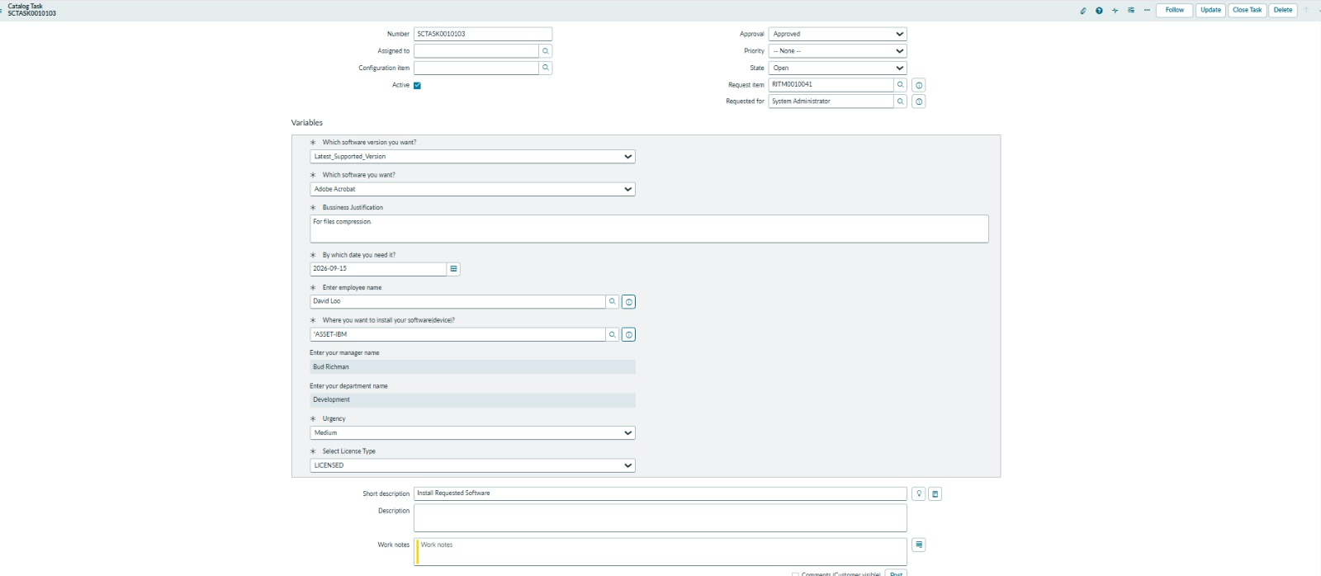
Fig 7.1 Licensed Software Request Catalog Item / Submitted Request
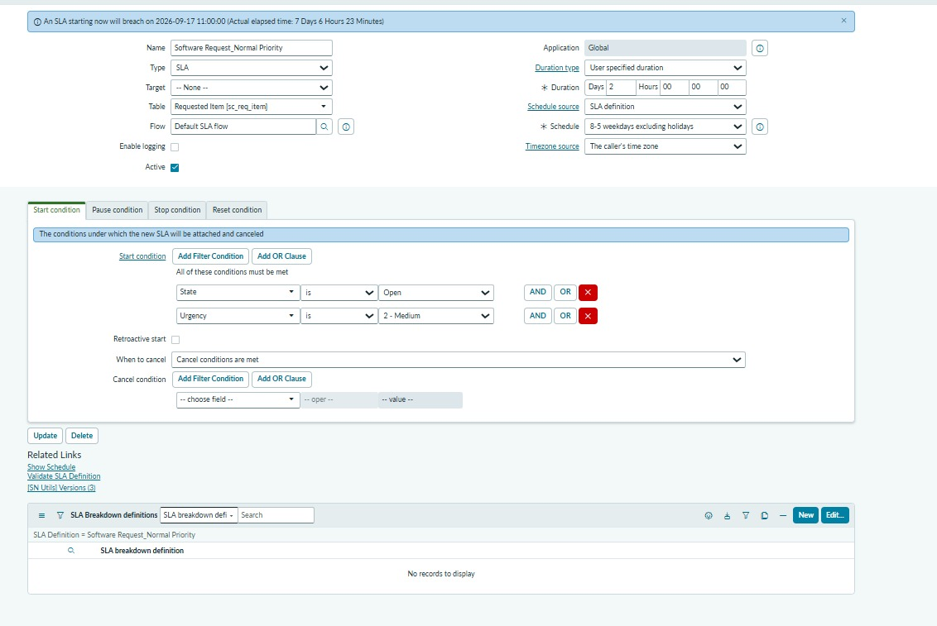
Fig 7.2 Configured Catalog Variables
Fig 7.3 Submitted Software Installation Request with Variables
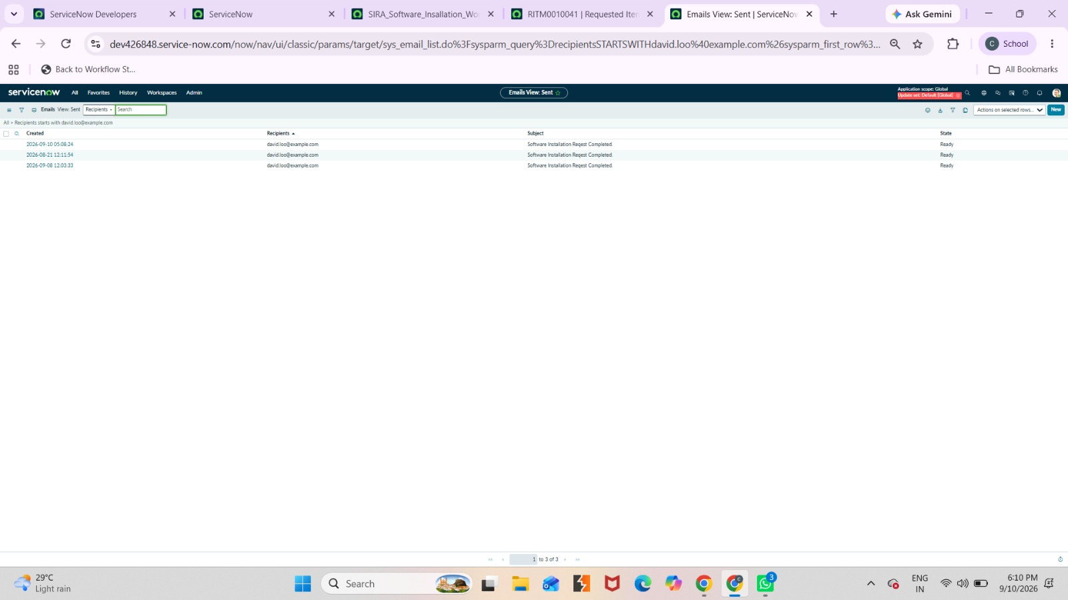
Fig 7.4 User-Friendly Service Catalog Form
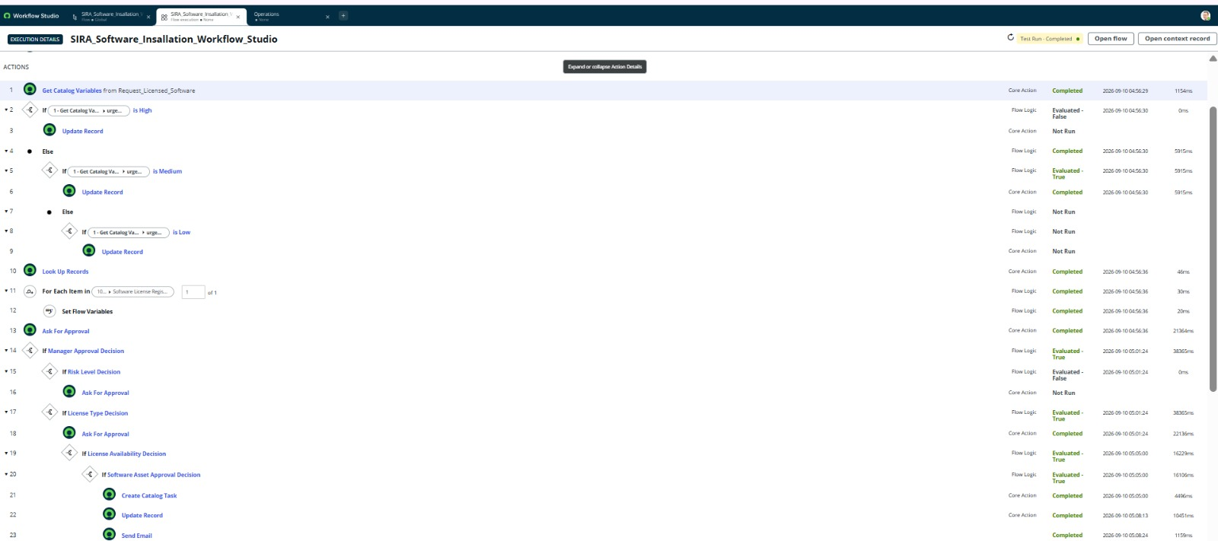
Fig 7.5 SIRA Software Installation Workflow – Workflow Automation Configuration
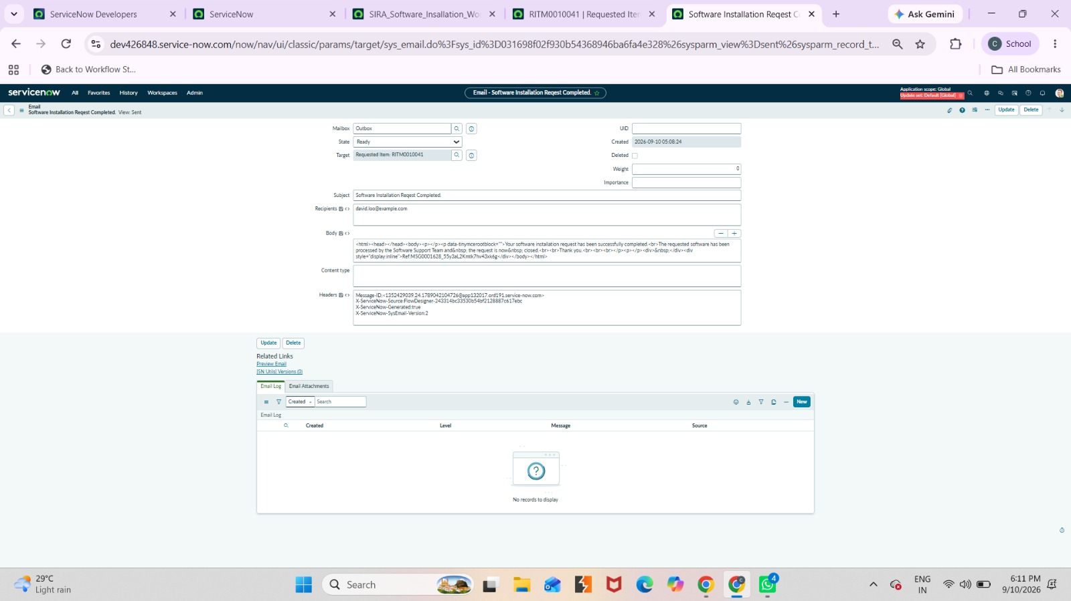
Fig 7.6 Approval Required Notification Configuration
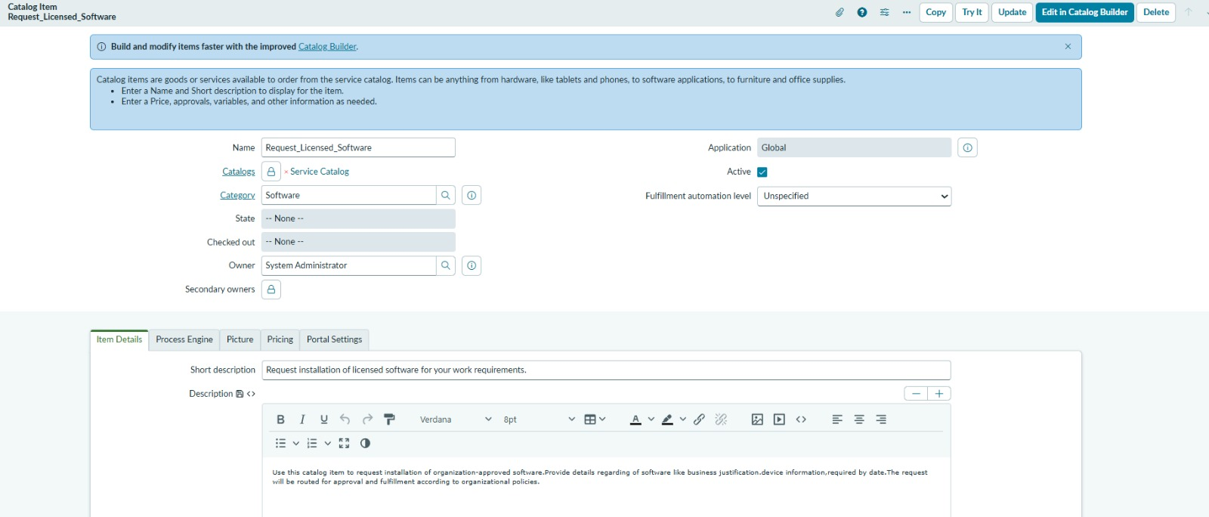
Fig 7.7 Approval / Decision Notification Configuration
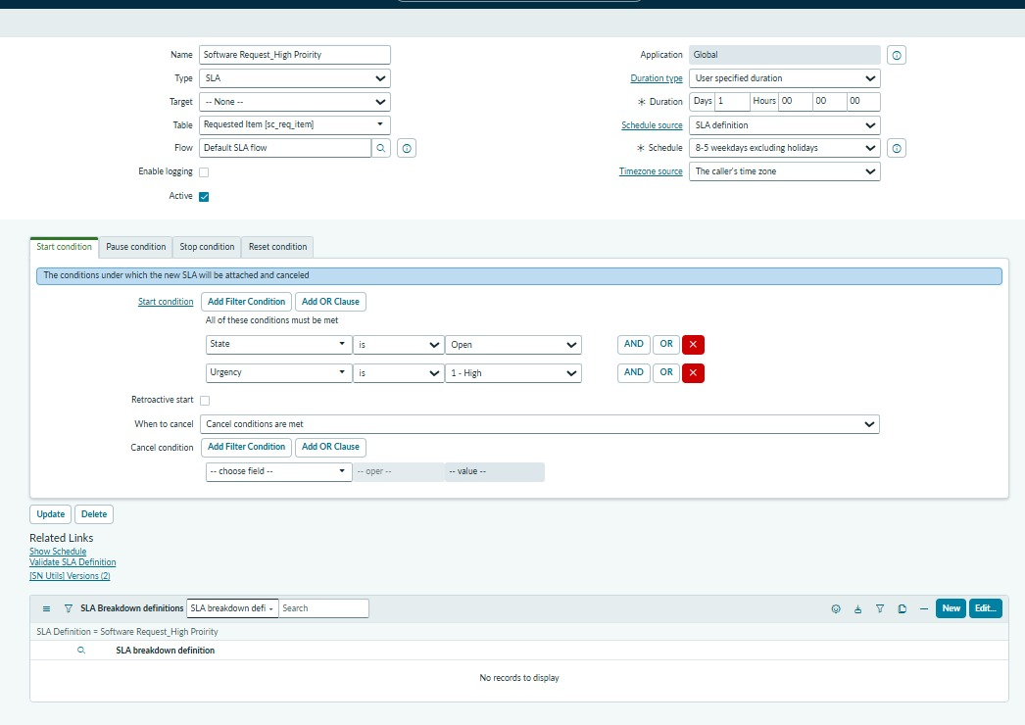
Fig 7.8 Software Installation Task / Assignment
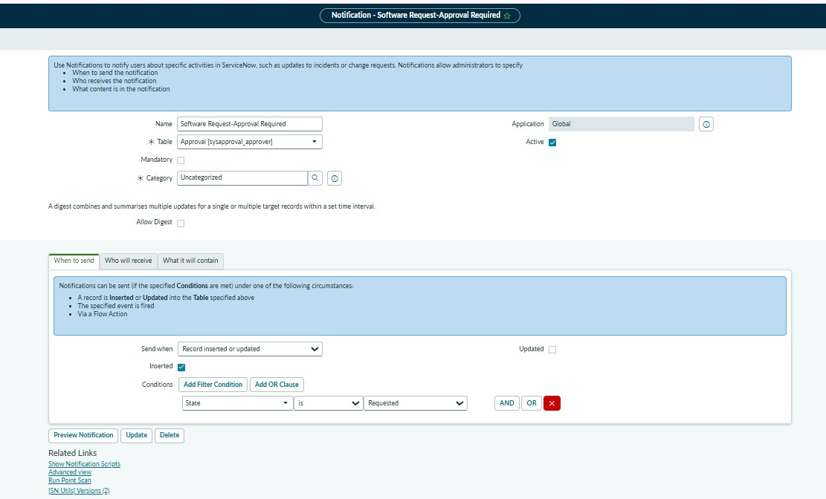
Fig 7.9 Fulfillment / Completion Evidence
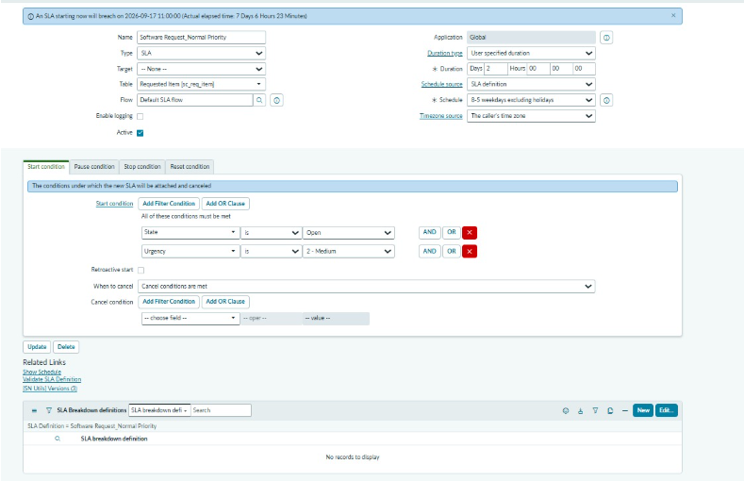
Fig 7.10 High Priority SLA / Service Configuration Evidence
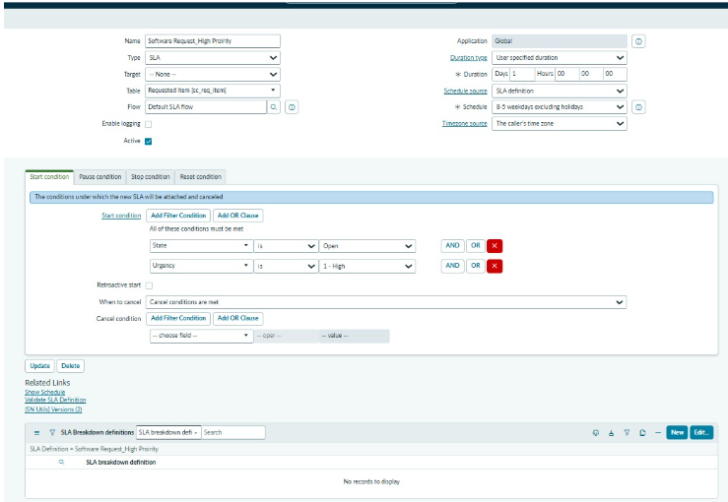
Fig 7.11 Normal Priority SLA / Service Configuration Evidence
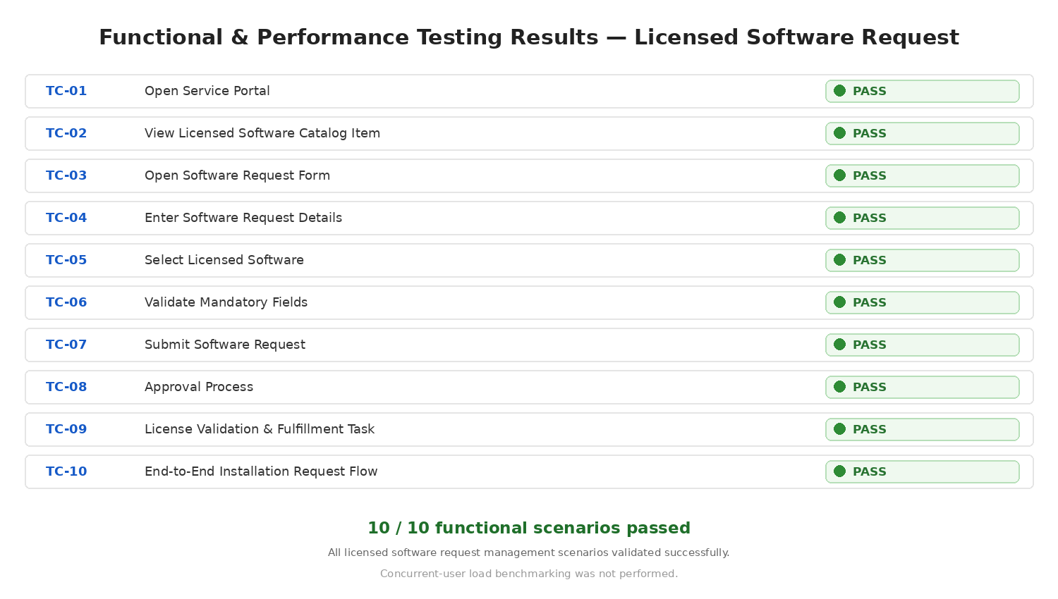
Fig 7.12 Functional and Performance Testing Results
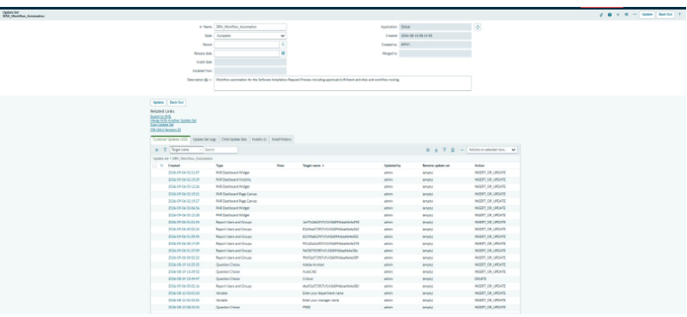
Fig 7.13 Update Set / Deployment Configuration Evidence

7.2 Work Item Status Validation
Component | Status | Validation
Licensed Software Request Catalog | Completed | Catalog item created and accessible
Catalog Variables | Completed | Required fields configured
UI Policies | Completed | Dynamic behavior configured
Catalog Client Scripts | Completed | Validation configured
License Validation | Completed | License check configured
Approval Process | Completed | Approval configured
SIRA Workflow | Completed | Workflow automation configured
Software Installation Task | Completed | Task created for fulfillment
Software Support Team | Completed | Fulfillment assignment configured
Notifications | Completed | Request events communicated
SLA | Completed | Priority-based SLA configured
Service Portal | Completed | Catalog accessible
Security | Completed | Roles and ACL controls configured
Dashboard | Completed | Request/license visibility configured
Update Set | Completed | Deployment package prepared

8. ADVANTAGES & DISADVANTAGES

Advantages
- Provides centralized licensed software request submission.
- Reduces incomplete request information.
- Improves request standardization.
- Automates license validation and approvals.
- Automatically creates fulfillment tasks.
- Improves visibility into the request lifecycle.
- Provides notifications and SLA monitoring.
- Reduces manual effort for the Software Support Team.
- Supports controlled deployment and auditability.

Disadvantages
- Depends on correct ServiceNow configuration.
- Initial configuration requires ServiceNow platform knowledge.
- Complex workflows may require additional maintenance.
- License data must be accurate for reliable validation.
- Advanced deployment integrations may require additional development.

9. CONCLUSION
The Licensed Software Installation Request through the Service Catalog system provides a structured approach to managing licensed software installation requests using ServiceNow.
The solution enables employees to submit requests through a centralized catalog, captures required information, validates request and licensing data, supports approval processing, and automates Software Installation Task creation. Tasks are assigned to the Software Support Team for fulfillment, while notifications, SLAs, dashboards, roles, and ACLs improve operational visibility and control.
The project demonstrates how ServiceNow capabilities such as Service Catalog, Catalog Variables, UI Policies, Catalog Client Scripts, Flow Designer / Workflow, Approval Engine, license validation, Task Management, Notifications, SLA, Security, and Update Sets can be combined to improve operational efficiency and the employee experience.

10. FUTURE SCOPE
The system can be enhanced in the future with:
- Integration with automated software deployment tools.
- Advanced dashboards and reporting.
- Real-time license inventory synchronization.
- Automatic priority calculation.
- Additional approval levels for restricted or high-cost software.
- Automatic license renewal and reclamation.
- Email and mobile notifications.
- AI-based request classification.
- Virtual Agent support.
- Knowledge articles for common software requests.
- Integration with endpoint management platforms.

11. APPENDIX

Appendix A – Technology Components
- ServiceNow Service Catalog
- Catalog Items
- Catalog Variables
- Catalog UI Policies
- Catalog Client Scripts
- Flow Designer / Workflow
- Approval Engine
- REQ and RITM Records
- License / Software Asset Information
- Software Installation Catalog Tasks
- sys_user
- sys_user_group
- Notifications
- SLA
- Roles and ACLs
- Dashboard
- Update Set

Appendix B – Project Flow
Employee Request → Service Catalog → Catalog Variables → REQ/RITM → License Validation → Approval → Software Asset Approval → Software Installation Task → Software Support Team → Installation → Notification → Closure

